Exercise 1:

1. Open Chrome browser

2. Maximize the browser window

3. Navigate to http://demo.guru99.com/test/drag_drop.html

4. Write a code to perform drag and drop operation from source to target.

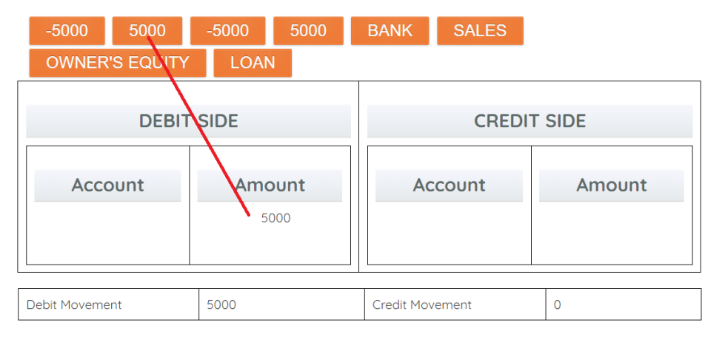

Exercise 2:

1. Open Chrome browser

2. Maximize the browser window

3. Navigate to http://demo.guru99.com/test/simple_context_menu.html

4. Verify “Double-Click Me To See Alert” displayed

5. Double-Click the button

6. Verify the alert displayed

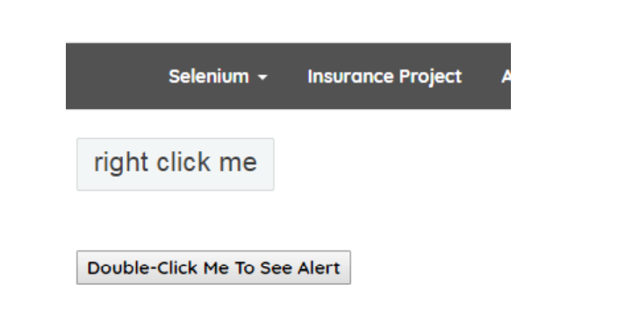

Exercise 3: Handling Windows

1. Go to [https://demoqa.com/browser-windows](https://www.toolsqa.com/automation-practice-switch-windows/)

2. Click on "New Window" button

4. Assert the text in new window equals “This is a sample page”

5. Close the new window

6. Click on "New Tab" button

7. Print the text in new tab

8. Close the new tab

Exercise 4:

1. Open Chrome browser

2. Maximize the browser window

3. Navigate to https://www.w3schools.com/html/tryit.asp?filename=tryhtml_iframe_height_width

webpage

4. Get and Check expected text as “This page is displayed in an iframe

